Flow of the Project

## ****Modules of Bike Rental System****

1. **Admin:** Admin will have the access to the overall System where he can add, update, view, and delete everything related to Products, Employees, and customers.
2. **User:**This module will allow users to first register into the system using their names, contact numbers, Mail IDs, and set passwords. Then a user can log in to the system using the registered name and password. Also, Users can log out of the system.
3. **Category**: In this module, Bikes can be categorized by Admin according to their brand’s names, charges per hour, models, colours, etc.
4. **Bike:** This module will manage all the Bikes related information like adding a new Bike to the system or viewing the old bikes and updating their information or deleting the ones not available for rent. This module consists of all the info regarding colour, weight, company, charges per hour, height, etc. related to the bike.
5. **Availability**: In this module, Admin can check whether the particular bike from a specific category is available for rent.
6. **Rent:** All operations related to renting a bike can be managed in this module. Users can rent a bike of their choice. Users can do the advance booking for renting a bike.
7. **Payment:** All operations related to payments done by users can be managed in this module.

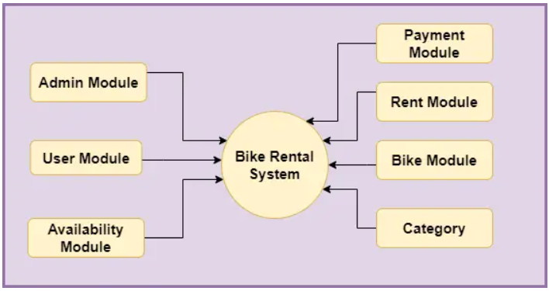

**Users Roles**

Two users can interact with this application **1) Admin 2) User**

1. **Admin Role**

* Can log in/log out of the system.
* Admin can view/edit/delete Bikes into the system.
* Can view/edit/delete Bike-Category into the system.
* Admin can view/confirm/cancel the booking of bikes rented by the User.
* Can check payments done by User.
* Can change charges per hour of bikes.
* Can change password.
* Can manage “My profiles”.

1. **User Role**

* Can log in/log out of the system.
* Can Manage “My profile”.
* Can search for bikes & two-wheelers.
* Users can rent bikes.
* Can make payments online.
* Can change password.

## ****Flow Diagram of Bike Rental System****

**Admin Flow**

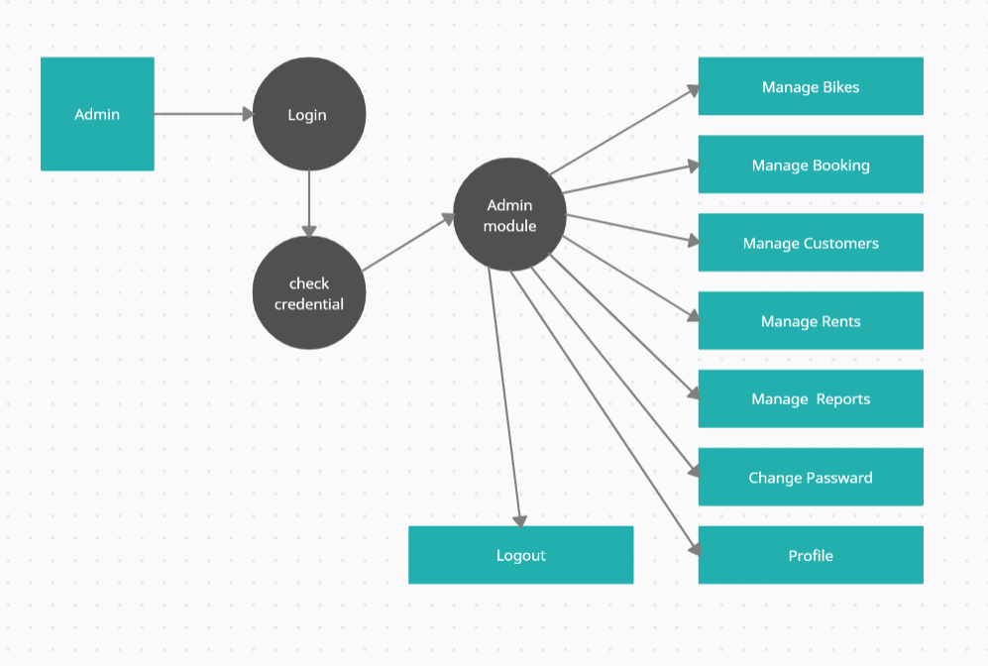

**User Flow**

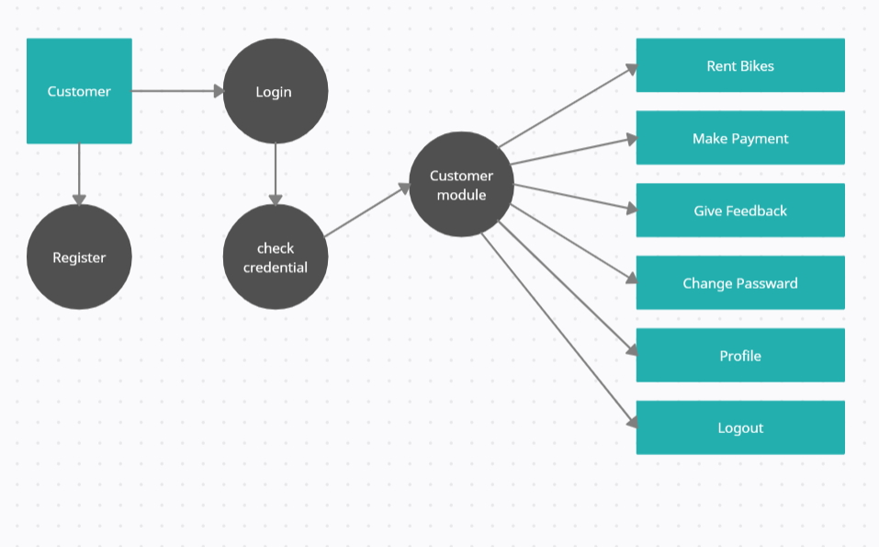

**ER Diagram**

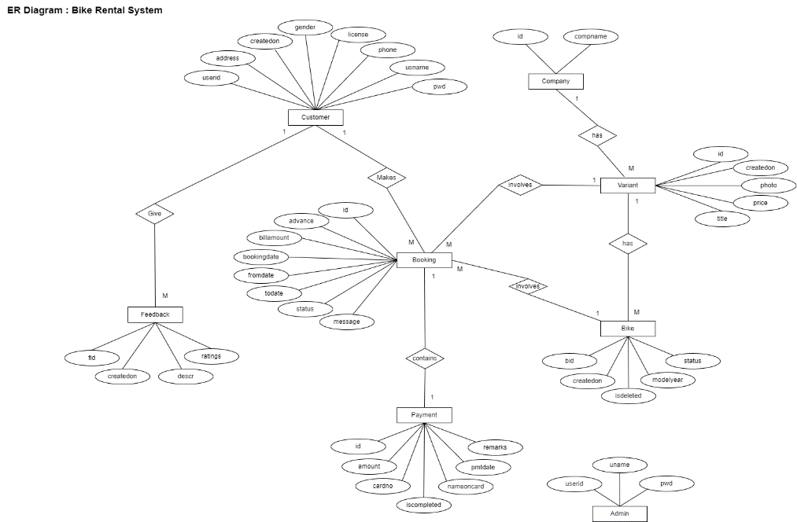

**Activity Diagram**

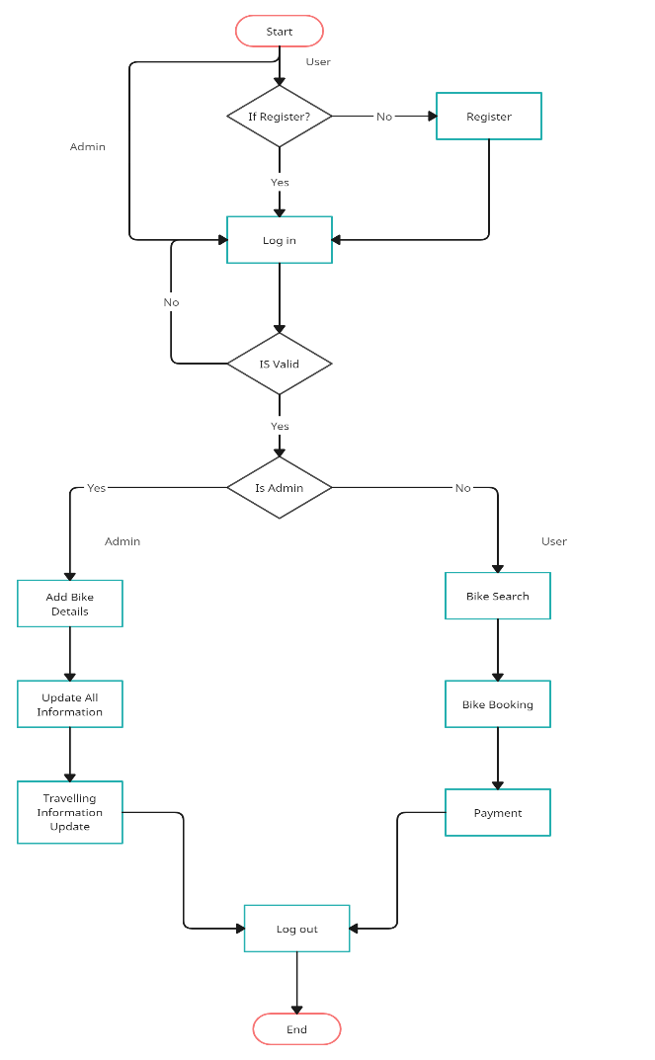

**Use case Diagram**

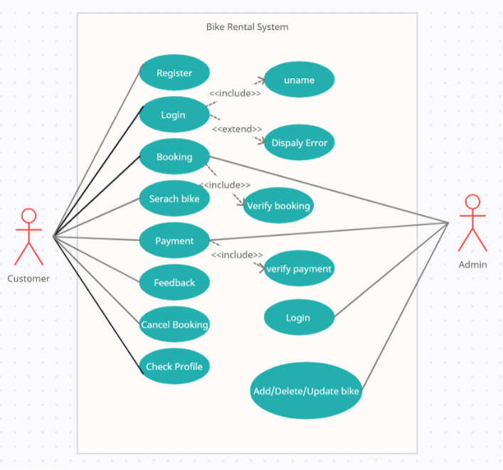

**Sequence Diagram**

